**Python Lab**

**Experiment 10 & 11 – OOPS**

**Date of Experiment: 22/04/2021**

**SAP ID: - 500085043**

**Name of the Student:- Akhand Pratap Singh**

**Q1.**

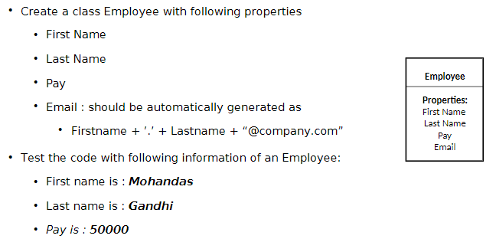

Screenshot of Code and Output

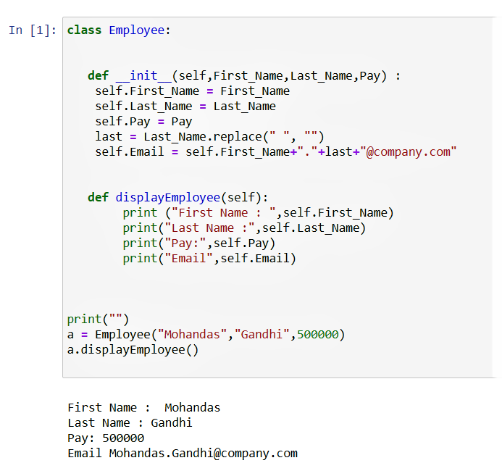

OTHER OUTPUTS



**Q2. Perform the following instructions:**

1. **Create a Vehicle class with max_speed and mileage as instance attributes. Additionally, create a method named seating_capacity() using the below syntax:**

**def seating_capacity(self, capacity):**

**return f"The seating capacity of a {self.name} is {capacity} passengers"**

1. **Create child class ‘Bus’ that will inherit all of the variables and methods of the Vehicle class. Set the seating capacity of the bus to 50 using super().**
2. **Create a Bus object that will inherit all of the variables and methods of the Vehicle class and display it.**
3. **Define a class attribute “color” with a default value white. I.e., Every Vehicle should be white.**

Screenshot of Code and Output**:**

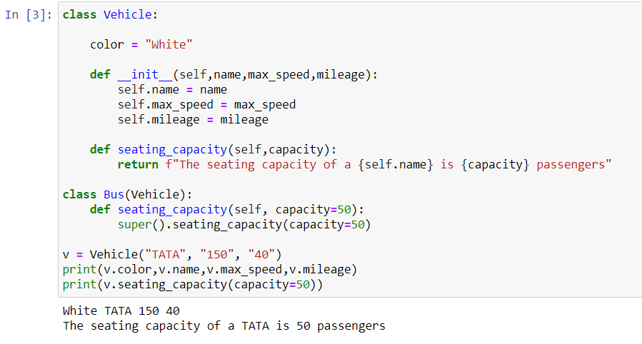

Question 3. List the risk associated with the implementation of Account class. Suggest a solution

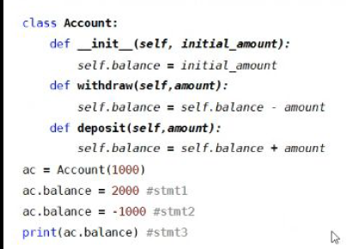

Screenshot of Correct Code and Output:

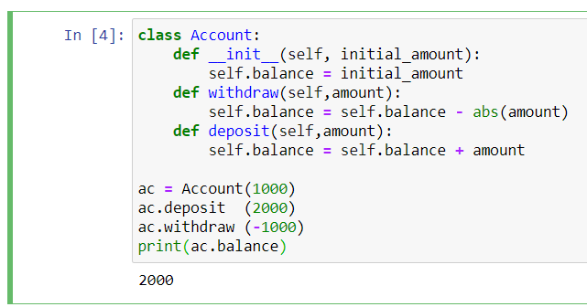

ANSWER:

* As we can see from the code the output is coming to be -1000 after giving two values for the parameter ac.balance i.e, simply we have to pass only one parameter otherwise it will change the value to the second one. This is first risk to be associated.
* **abs() has to be used with the withdrawal amount because if the negative amount deducted will not be added to the existing balance.**
* **self.balance = self.balance – amount**

**This is wrong because if the amount is negative the balance will increase which is not logically correct as withdrawal means deduction of the amount present in the account.**

* **self.balance = self.balance - abs(amount)**

**This will be the correct format**

* **ac.balance code has been used twice. insted of deposited and withdrawn**
* **The value should be passed without = sign**

**ac.deposit = 2000 --Incorrect syntax**

**ac.deposit(2000) –Correct syntax**